QUESTION BANK

SOFTWARE ENGINEERING 2

• You are appointed as a consultant for the computerization of the hospital management systems. How can you integrate class diagram and use case, dynamic model for the data structure design in object technology? Justify your answer by designing the data structure and algorithms for the following scenario:

• The hospital wishes to maintain a database to assist with the administration of its wards and operating theatres, and to maintain information relating to its patients, surgeons and nurse. Most patients are assigned to a ward on admittance and each ward may contain many patients. However, consultants (senior surgeons) at the hospital may have private patients who are assigned to private rooms and general wards. A ward and theatre may have many nurses assigned to it. Each ward is dedicated to a particular type of patient (e.g. pediatric, maternity, Accident etc.).The information to be recorded about an operation includes the type of operation, the patient, the surgeons involve, date, time and location. Only one surgeon may perform an operation, any other surgeons present being considered as assisting at the operation. After the release of the patient, the payment bill may be given to the discharged patient.

Construct the following:

(a) Component Diagram (10 Marks )

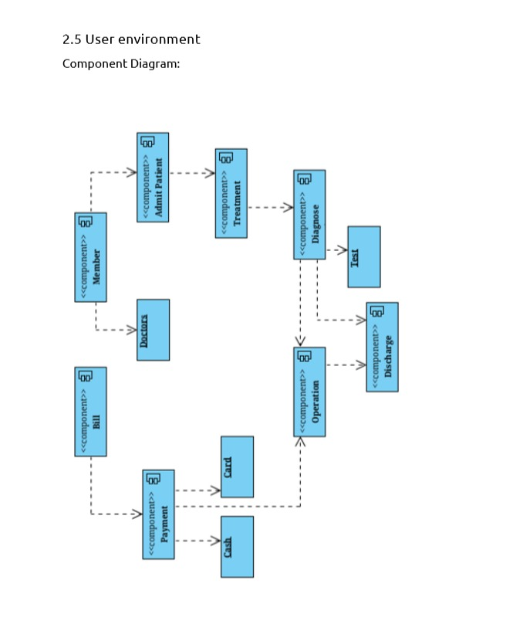

(b) Deployment Diagram ( 10 Marks)

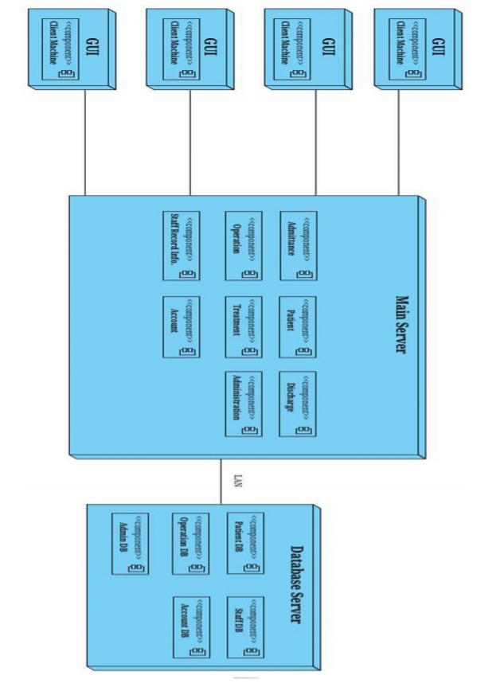

• **The Mumbai University Result Management Systems :** The Mumbai University offers several engineering collages with different programs(branches) for the students..In the university result management systems, the students has to appear for practical examination(100 Marks ) and theory examination(100 Marks). The theory examination is the continuous assessment based on Test One(10 Marks), Test Two(10Marks), Middle Semester Exam(MST)-(20 Marks) and End Semester Examination(ESE)-60 Marks and the results of the students are declared on the basis of practical examination and theory examination. For this case study , answer the following questions.

(i)Construct the class diagram for the University Result management systems; clearly specify all attributes and methods with access specifiers and constraints.

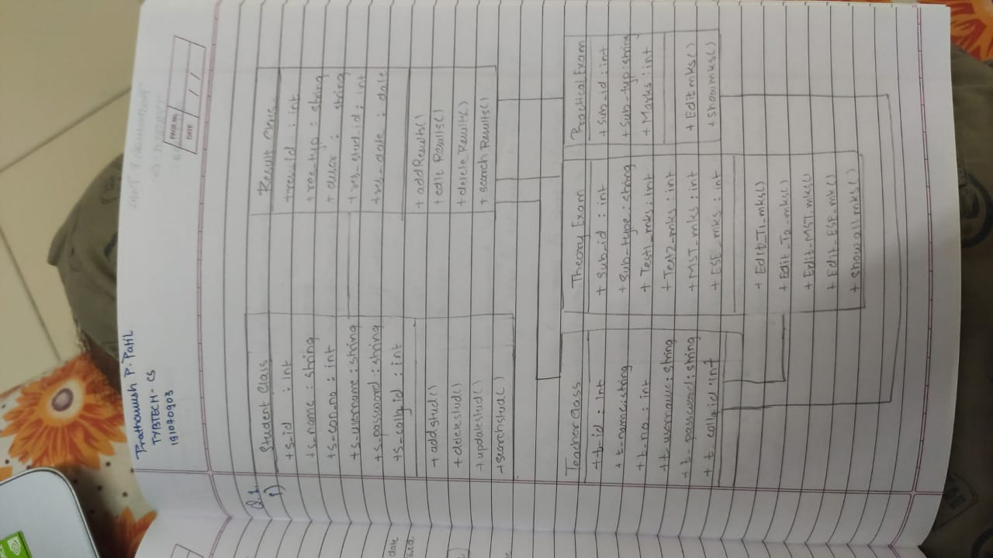

**OR**

(ii)Give data and process model design for **Mumbai University Result Management Systems** using C++ or JAVA.

Construct the following:

(a) Component Diagram (10 Marks )

(b) Deployment Diagram ( 10 Marks)

Or Give the software Architecture (Component Diagram, data structure, Algorithms design And Deployement Diagram) ( 20 Marks )

**Q5. Case Study Marrige :** Suppose we have three men *m*1, *m*2, and *m*3 and three women *w*1, *w*2, and *w*3. Furthermore, suppose that the preference rankings of the men for the three women, from highest to lowest, are*m*1:*w*3,*w*1,*w*2; *m*2:*w*1,*w*2,*w*3;*m*3: *w*2, *w*3, *w*1; and the preference rankings of the women for the three men, from highest to lowest, are *w*1: *m*1, *m*2, *m*3; *w*2: *m*2, *m*1, *m*3; *w*3: *m*3, *m*2, *m*1. For each of the six possible matchings of men and women to form three couples, determine whether this matching is stable.

The **algorithm**, can be used to construct a stable matching of men and women. In this algorithm, members of one gender are the **suitors** and members of the other gender the **suitees**. The algorithm uses a sequence of rounds; in each round every suitor whose proposal was rejected in the previous round proposes to his or her highest ranking suitee who has not already rejected a proposal from this suitor. A suitee rejects all proposals except that from the suitor that this suitee ranks highest among all the suitors who have proposed to this suitee in this round or previous rounds. The proposal of this highest ranking suitor remains pending and is rejected in a later round if a more appealing suitor proposes in that round. The series of rounds ends when every suitor has exactly one pending proposal. All pending proposals are then accepted.

**1.** Design/Give the algorithm for this marriage case study.

**2.** Show that the algorithm terminates.

**3.** Show that the algorithm always terminates with a stable assignment.

Solution:

Ans for 1st:

Algorithm 1 Updated Gale-Shapley algorithm

1: Initially all m ∈ M and w ∈ W are free

2: while there is a man m who is free and hasn’t proposed to every woman on his preference list do

3: Choose such a man m

4: Let w be the highest-ranked woman in m’s preference list to whom m has not yet proposed

5: if w is free and m is on w’s preference list then

6: (m, w) become engaged

7: else if w is currently engaged to m0

8: if m is not on w’s preference list or w prefers m0 to m then

9: m remains free and (m, w0 ) remain engaged

10: else if m is on w’s preference list and w prefers m to m0

11: (m, w) become engaged and m0 becomes free

12: end if

13: end if

14: end while

15: Return the set S of married pairs

Steps for checking stability answer for 2nd and 3rd:

Link to verify [Steps for stability](https://www.slader.com/discussion/question/suppose-we-have-three-men-m1-m2-and-m3-and-three-women-w1-w2-and-w3-furthermore-suppose-that-the-pre/)